Testing a model to track marine fish migrations in polar regions using satellite tags

*Bjørn Ådlandsvik¹, Cedar M. Chittenden², Ole-Petter Pedersen², David Righton³ and Audun H. Rikardsen²

¹Institute of Marine Research, P.O. Box 1870, Nordnes, N-5817 Bergen, Norway
²Department of Arctic and Marine Biology, University of Tromsø, N-9037 Tromsø, Norway
³Center for Environment, Fisheries and Aquaculture Science, Pakefield Road, NR33 0HT Lowestoft, UK

*Correspondence. e-mail: bjorn.adlandsvik@imr.no

Abstract

The use of satellite tags to geolocate marine fishes in polar regions is challenging due to the briefness of temporal periods with a defined sunrise and sunset. Models using other environmental parameters, such as temperature and depth, are thus required to supplement geolocation data in the estimation of marine migratory routes. A forward/backward-Lagrangian model using biased random walks was adapted to satellite tag data from a migrating Atlantic salmon (Salmo salar), and known geolocations were used to test and constrict the model. Sensitivity analyses demonstrated that slight alterations in start and end points do not significantly affect mean migratory route estimates. (Add further conclusions, discussion)

Key words: Atlantic salmon, forward/backward-Langrangian, PSAT, Arctic, fish, SST, temperature, depth, telemetry, archival tag (pick which ones to use)

Introduction

Satellite telemetry has been used for decades to track marine migratory species, including reptiles (e.g. Luschi et al., 1996; Hughes et al., 1998), birds (e.g. Jouventin and Weimerskirch, 1990; Georges et al., 1997), and mammals (e.g. Lowry et al., 1998; Richards et al., 1998). As satellite tags do not require an animal to be recaptured in order for data to be obtained, they are particularly useful for species with long migrations in the open ocean (Mate et al., 1998; Gillespie, 2001). However, for data to be uploaded to a satellite, the tag’s antenna must be pointing upward and in air –making the study of most fish species all but impossible. Pop-up satellite archival tags, or PSATs, are a recently developed technology for the study of aquatic species (Microwave Telemetry Inc., Baltimore, MD). PSATs are buoyant and can be programmed to release from a tagged animal on a certain date, or when an animal has remained at a constant depth for a pre-determined period of time (a probable mortality). Once at the surface, the tag transmits the stored environmental data to passing satellites. PSATs have been tested on several large marine fish species (e.g. Lutcavage et al., 1999; Arrizabalaga et al., 2008) and have recently been made small enough to be used on smaller fish (Aarestrup et al., 2009).

PSAT tags generally record the temperature and depth of a tagged animal at regular time intervals, although other types of environmental sensors can be attached (e.g. salinity, chlorophyll recorders (ref). Geolocation estimates by PSAT tags are calculated using sunrise and sunset measurements. Therefore, at polar latitudes the tags can estimate geolocation only during brief periods before and after the spring and autumn equinoxes (Fig. 1). Even during these periods of possible geolocation, the difference in irradiance between day and night is much less than in tropical regions, adding error to estimates. Furthermore, the duration of twilight is greater at higher than at lower latitudes, making the estimation of exact sunrise and sunset time challenging, especially with additional confounding factors acting to lower light levels (e.g. diving behaviours or adverse weather conditions).

Information on the migration and distribution of fishes at high latitudes is highly important, however, as these areas support some of the most lucrative fisheries in the world, and many are becoming severely depleted (Sakshaug et al. 2009). For example, anadromous Atlantic salmon (Salmo salar) and Pacific salmon species (Oncorhynchus spp.) undertake long feeding migrations into northern oceans where observational studies are challenging (Hansen and Quinn, 1998; Rikardsen et al., 2008). Salmonids are described as surface-oriented species, using the top 10 m of the water column for primary habitat during their saltwater phase (Rikardsen and Dempson, 2010). The open-ocean migratory behaviour of salmonids has been pieced together in the past from fishing catch data and mark-recapture studies (Hansen et al., 2000; Rikardsen et al., 2008). In short, there exists almost no data beyond commonly fished areas. Thus, without any continuous, real-time data, great knowledge gaps exist in terms of the actual marine distribution of salmon, salmonid migratory routes, and environmental effects on salmonid marine behaviour (Chittenden et al., 2009). Satellite tags are perhaps the only technology currently available that could enable researchers to overcome this problem and fill the existing gaps. However, with the difficulties associated with light geolocation at polar latitudes, additional methods are required.

Models have been developed that can reconstruct the horizontal movements of migrating fish using only temperature and depth (Metcalfe and Arnold, 1997; Tremblay et al., 2009). A number of different approaches have been applied to the problem of predicting the state-space of migrating organisms –many of which are also commonly used for modeling the dispersal of passive drifters. In general, they differ with respect to the applied theoretical frameworks, forcing fields and data assimilation methods, i.e. to which extent the model is able to incorporate and use external data as correctors. Our model approach is classified as a Biased Random Walk (BRW; Patterson et al., 2007; Ådlandsvik et al., 2007). Satellite-based geolocation, as well as other advanced data recording technologies are becoming more widely used for data assimilation. With respect to theoretical frameworks in migratory models, various statistical techniques are common, including Bayesian models (Kurota et al., 2009), bootstrapping techniques (Tremblay et al., 2009) and weighted kernel estimation techniques (Walli et al., 2009). In the context of passive drifters, hydrodynamical fields are classically used to advect organisms (Pedersen et al., 2000, 2003; Batchelder, 2006). However, modeled physical fields have also been applied to describe the migration of self-motile organisms, particularly in the sense of rehotaxis and thermotaxis (Booker et al., 2008). The horizontal migratory behaviour of cod was estimated using a forward/backward Lagrangian model with a Biased Random Walk (Ådlandsvik et al., 2007). Although cod migratory behaviour differs considerably from that of salmon (cod are slower-moving bottom dwellers), with known geolocation points to validate and constrict the model, it can be adapted to salmon data. Thus, the objectives of our work were fourfold:
- To adapt the method of Ådlandsvik et al. (2007) to salmon behaviour data,
- To test the accuracy of the model with PSAT geolocation data,
- To run a sensitivity analysis on the model, altering the release and pop-up locations, and
- To use the geolocations as stop/start points to constrain the model and improve the precision of the tracks.

materials and Methods

Modell description

The model creates a set of trajectories consistent with the available information from the tag. Two sets of trajectories are generated –one from the initial and one from the final position. The trajectories move by a deterministic and stochastic velocity component. The deterministic component gives a pull in the right direction; more precisely, it is the velocity that would get the particle to the final position in the time available. The stochastic component is a random walk velocity, with a fixed speed and an arbitrary direction.

After each time step, the environmental dataset is sampled at the position of the trajectory. If the tag data are not consistent with the new position, the trajectory gets a second chance by sampling at the previous position. An effect of this is that the trajectories are confined to the sea. If the old position also fails, the trajectory is terminated. As a finale step, the forward and backwards trajectories are merged at half time between release and pop-up. This is done by looping through the active forward trajectories and choosing the nearest backwards trajectory if the mid-time positions are closer than a given threshold.

The procedure can be viewed as similar to natural selection. Many trajectories are generated; most are terminated by passing through an inconsistent position at some time along their track. It would be possible to develop the model into a genetic algorithm by spawning new generations of trajectories as perturbations of the successful ones in the previous generation. This has not yet been implemented. The model is described further in Ådlandsvik et al. (2007).

Model set up

Two environmental data sets have been used –bathymetry and sea surface temperature (SST). For bathymetry, we have used the gridded ETOPO1 dataset provided online by the NOAA National Geophysical Data Center from their Web site at http://www.ngdc.noaa.gov/mggd/ (Amante and Eakins, 2009). This data set has a resolution of one minute. For SST, we have used the gridded dataset NOAA_OI_SST_V2 provided online by the NOAA Earth System Laboratory from their Web site at http://www.esrl.noaa.gov/psd/ (Reynolds et al., 2002). This dataset has one degree spatial and one week temporal resolution. The datasets are sampled at the track positions by (multi-)linear interpolation.

The tag data (real resolution) are prepared by computing hourly averages of SST and hourly maximum depth. Missing data (mostly due to lack of surface temperature within the hour) are filled by linear interpolation. The tag data show some rapid change in surface temperature which is impossible to follow given the lower resolution of the SST archive. The tag temperature data are therefore smoothed by a .... days moving average.

Sub-grid variation is also accounted for by thresholds for termination. These thresholds are somewhat arbitrarily determined by trial and error. They should be tight so that the termination criteria become effective and provide a good selection pressure for the trajectories. On the other hand, they should allow for non-resolved variation and leave a reasonable subset of active trajectories.

For depth, it is not easy to determine if the salmon has been at the bottom, Therefore depth is used as a one-sided limiter terminating trajectories where the sampled depth Hetopo is too shallow compared to the tag depth. The limiter has the following algebraic formulation:
H_{tag} < a*H_{etopo} + H₀

For temperature a symmetric two-sided criterion is used. The trajectory must satisfy the criterion:
| T_{SST} - T_{tag} | < dT

The values used are given in the table below.

[Here comes a table with different settings]

T: average temperature at 0 m by day
D: maximum daily depth (* 1.3 + 30)

The salmon data
The individual PSAT dataset from a salmon kelt was used to test the model. ‘Kelt’ is the term given to a post-spawned adult salmon that leaves its freshwater spawning grounds to return to ocean feeding areas. The fish was caught by anglers during late May in the Alta River (70°N 23°E), northern Norway (Fig. 2). A PSAT tag recording temperature, depth and geolocation (Microwave Telemetry, Inc.) was attached to the fish externally. The tag and its attachment were harnessed to two backplates on either side of the fish’s dorsal fin. An acoustic tag was also attached to one of the backplates so that the exact time of fjord exit could be ascertained. Following surgery, the tagged salmon was transported to the release site (Fig. 2) by boat. The fish in this study was a 100.5 cm long, 9.9 kg female. She was released 22 May 2008 and took three days to leave the release fjord.

The tag released from its attachment for reasons of constant depth following four consecutive days at the surface. It is probable that the tag and harness detached somehow from the fish (possibly predation) and floated to the surface as one unit. Thus, the tag was likely drifting with surface currents for four days prior to the initialisation of uploading to the ARGOS satellites. For the actual pop-up location to be ascertained, a back-calculation was required. Real-time ARGOS geolocation data from the four days following the initiation of the data upload were used to determine the change in latitude and longitude experienced by the tag due to current. These latitudinal and longitudinal differences were then subtracted from the geolocation at the start of the upload.

Validation of PSAT geolocations
Unlike PSAT data obtained at lower latitudes, the longitude estimates from tags deployed in polar regions are unreliable during most of the year. This precludes the use of established validation methods, where longitude is ‘fixed’ and matched with SST data at a range of latitudes (e.g. Teo et al., 2004). Another method was developed here to validate the geolocations from polar latitudes.

Four different estimates of SST were calculated from the salmon PSAT data, including average temperature (day) at water depths shallower than 5.5m, average temperature (day) at a depth of 0 m, maximum temperature (day) at a depth of 0 m, and minimum temperature (day) at a depth of 0 m. The SST data for each geolocation requiring validation were extracted from daily SST maps from OSTIA (Stark et al., 2007). The SST data have an RMS error <0.6°C. The SST values for a 0.5° latitude and longitude area, centred on the geolocation, were also extracted, and the maximum and minimum were compared to each of the four different estimates of SST from the tag. The geolocations were then classed as validated if the four tag SST values were within 0.5°C of the OSTIA SST. The mid-points of the OSTIA SST temperatures from each latitude were collated and a linear regression performed.

Results

Validated geolocations
Figure 3. Map of geolocation validation method (DR)
Parameters for rejection
Percentages by reason of rejection
Describe validated locations

Testing the model
Figure 4. Track plot of 83101 using t and d with geolocation
See Ådlandsvik et al 2007, model description after that, how it was changed
Result of the model showing mean and geolocation points in order.
Path taken by the fish, time steps
How many trajectories, trends in pathways used
How the mean changes with altering temp and depth parameters
Figure 5. 8 snapshots showing density of possible locations, actual geolocation (BÅ)
Model fits geolocations in 6/8 cases… (3 and 4 don’t fit so well)

Sensitivity analysis
Minor modifications of release and pop-up locations do not change the overall pattern formed by the data from the tag and the environment (Fig. 6). Mean is robust, does not depend critically on release and pop-up location (error range?)

Constraining the model
Figure 7. Best estimate plot funnelled through geolocations

Discussion

Analysis of reasons for max extinctions
Table 2: reasons for termination of trajectories.
Figure 8: tag temperature and depth data, highlight deep points (or could be mentioned earlier in methods, salmon data section).

Possible references to include:
(Metcalfe and Arnold 1997) using depth and temperature to track plaice with confirmation by geolocation.
(Tremblay et al., 2009) bootstrapping random walks biased by forward particles, uses recorded data accuracy estimates, assimilates other sources of data like SST, depth, boundaries. Tested using ARGOS and geoloc tracks from seals.
(Tremblay et al., 2006) interpolation of geolocation using 6 algorithms. Bezier, hermite and cubic splines, linear algorithm. Interpolated tracks compared to intact tracks. Tracks were more accurate using curvilinear interpolation.
(Christensen et al., 2007) hydrodynamical and individual-based model to look at larval backtracking
(Kurota et al., 2009) spatially structured Bayesian model applied to PSAT, DST, conventional tags to look at mortality rates and movement.
(Booker et al., 2008) model to simulate migration of Atlantic salmon using random swimming direction, rehotaxis and thermotaxis as time steps.
(Walter et al., 1997) spatially explicit individual-based modelling using surface currents and behavioural rules for Pacific salmon.
(Patterson et al., 2007) Review of state-space models of individual animal movement.
(Jonsen et al., 2003) meta-analysis of animal movement using state-space models
(Jonsen et al., 2005) state-space modell of three seal pathway sets
(Walli et al., 2009) weighted kernel estimation technique to remove bias of deployment location and track length

conclusion
Other possible applications of this method (other geolocation types, other organisms, etc.)

Acknowledgements
We thank Jenny Jensen, Ceselie Lien, Amund Suhr, the Alta Laksfiskeri I, fishermen. Funding agency. Kathrine Michalsen.

References
Aarestrup, K., Økland, F., Hansen, M.M., Righton, D., Gargan, P., Castonguay, M., Bernatchez, L., Howey, P., Sparholt, H., Pedersen, M.I. and McKinley, R.S. (2009) Oceanic Spawning Migration of the European Eel (Anguilla anguilla). Science 325:1660.
Amante, C. and Eakins, B.W. (2009) ETOPO1 1 Arc-Minute Global Relief Model: Procedures, Data Sources and Analysis. NOAA Technical Memorandum NESDIS NGDC-24, 19 pp, March 2009.
Arrizabalaga, H., Pereira, J.G., Royer, F., Galuardi, B., Goni, N., Artetxe, I., Arregi, I. and Lutcavage, M. (2008) Bigeye tuna (Thunnus obesus) vertical movements in the Azores Islands determined with pop-up satellite archival tags. Fish. Oceanog. 17:74–83.
Batchelder, H.P. (2006) Forward-in-time-/backward-in-time trajectory (FITT/BITT) modeling of particles and organisms in the coastal ocean. Am. Meteor. Soc. 23:727-741.
Booker, D.J., Wells, N.C. and Smith, P.I. (2008) Modelling the trajectories of migrating Atlantic salmon (Salmo salar). Can. J. Fish. Aquat. Sci. 65:352-361.
Chittenden, C., Beamish, R.J and McKinley, R.S. (2009) A critical review of Pacific salmon marine research relating to climate. ICES J. Mar. Res. 66:2195-2204.
Georges, J., Guinet, C., Jouventin, P. and Weimerskirch, H. (1997) Satellite tracking of seabirds: interpretation of activity pattern from the frequency of satellite locations. IBIS. 139:403–405.
Gifford, A., Compagno, L.J.V., Levine, M. and Antoniou, A. (2007) Satellite tracking of whale sharks using tethered tags. Fish. Res. 84:17–24.
Gillespie, T.W. (2001) Remote sensing of animals. Progr. Phys. Geog. 25:355-362.
Hansen, L.P. and Jacobsen, J.A. (2000) Distribution and migration of Atlantic salmon Salmo salar L., in the sea. In: The Ocean Life of Atlantic Salmon – Environmental and Biological Factors Influencing Survival. D. Mills (ed). Oxford: Fishing News Books, pp. 75–87.
Hughes, G.R., Luschi, P., Mencacci, R. and Papi, F. (1998) The 7000-km oceanic journey of a leatherback turtle tracked by satellite. J. Exp. Mar. Biol. Ecol. 229:209–17.
Jerlov, N.G. and Nielsen, E.S., Eds. (1974) Optical aspects of oceanography. Academic Press, London, New York. 494 pp.
Jouventin P. and Weimerskirch, H. (1990) Satellite tracking of wandering albatrosses. Nature 343:746–748.
Kurota, H., McAllister, M.K., Lawson, G.L., Nogueira, J.I., Teo, S.L.H. and Block, B. (2009) A sequential Bayesian methodology to estimate movement and exploitation rates using electronic and conventional tag data: application to Atlantic bluefin tuna (Thunnus thynnus). Can. J. Fish. Aquat. Sci. 66:321-342.
Lowry, L.L., Frost, K.J., Davis, R., DeMaster, D.P. and Suydam, R.S. (1998) Movements and behavior of satellite-tagged spotted seals (Phoca largha) in the Bering and Chukchi Seas. Polar Biol. 19:221-230.
Luschi, P., Papi, F., Liew, H.C. and Chan, E.H. (1996) Long-distance migration and homing after displacement in the green turtle (Chelonia mydas): a satellite tracking study. J. Comp. Physiol. 178:447–52.
Lutcavage, M.E., Brill, R.W., Skomal, G.B., Chase, B.C. and Howey, P.W. (1999) Results of pop-up satellite tagging of spawning size class fish in the Gulf of Maine: do North Atlantic bluefin tuna spawn in the mid-Atlantic? Can. J. Fish. Aquat. Sci. 56:173–177.
Mate, B.R., Gisiner, R. and Mobley, J. (1998) Local and migratory movements of Hawaiian humpback whales tracked by satellite telemetry. Can. J. Zool. 76:863–68.
Metcalfe, J.D. and Arnold, G.P. (1997) Tracking fish with electronic tags. Nature 387:665–666.
Patterson, T.A., Thomas, L., Wilcox, C., Ovaskainen, O. and Matthiopoulos, J. (2007) State-space models of individual animal movement. Trends Ecol. Evol. 23:87-94.
Pedersen, O.P., Tande, K.S. and Slagstad, D. (2000) A synoptic sampling method applied to Calanus finmarchicus population on the Norwegian mid-shelf in 1997. Mar. Ecol. Prog. Ser. 204:143-157.
Pedersen O.P., Aschan, M., Rasmussen, T., Tande, K.S. and Slagstad, D. (2003) Larval dispersal and mother populations of Pandalus borealis investigated by a Langrangian particle-tracking model. Fish. Res. 65:173-190.
Reynolds, R.W., Rayner, N.A., Smith, T.M., Stokes, D.C. and Wang, W. (2002) An improved in situ and satellite SST analysis for climate. J. Climate 15:1609-1625.
Richards, P.R., Heide-Jorgensen, M.P. and Aubin, D.S. (1998) Fall movements of Belugas (Delphinapterus leucas) with satellite-linked transmitters in Lancaster Sound, and northern Baffin Bay. Arctic 51:5–16.
Rikardsen, A.H., Hansen, L.P., Jensen, A.J., Vollen, T. and Finstad, B. (2008) Do Norwegian Atlantic salmon feed in the northern Barents Sea? Tag recoveries from 70 to 78°N. J. Fish Biol. 72:1792-1798.
Stark, J.D., Donlon, C.J., Martin, M.J. and McCulloch, M.E. (2007) OSTIA : An operational, high resolution, real time, global sea surface temperature analysis system., Oceans '07 IEEE Aberdeen, conference proceedings. Available online at http://ghrsstpp.metoffice.com/pages/latest_analysis/ostia.html
Teo, S.L.H., Boustany, A., Blackwell, S., Walli, A., Weng, K.C. and Block, B.A. (2004) Validation of geolocation estimates based on light level and sea surface temperature from electronic tags. Mar. Ecol. Prog. Ser. 283: 81-98.
Tremblay, Y., Robinson, P.W. and Costa, D.P. (2009) A parsimonious approach to modelling animal movement data. PLoS ONE. 4:e4711.
Walli, A., Teo, S.L.T., Boustany, A., Farwell, C.J., Williams, T., Dewar, H., Prince, E. and Block, B. (2009) Seasonal movements, aggregations and diving behaviour of Atlantic bluefin tuna (Thunnus thynnus) revealed with archival tags. PLoS ONE. 4:e6151.
Ådlandsvik, B., Huse, G. and Michalsen, K. (2007) Introducing a method for extracting horizontal migration patterns from data storage tags. Hydrobiologia 582:187-197.

FIGURES

Figure 1. The theoretical light intensity at sea surface as a function of latitude and time (calculated according to Jerlov and Nielsen, 1974). Whereas geolocation is possible at all times of the year near from the equator to the polar circles, at polar latitudes (75°N), geolocation zones are limited (shaded area).

Figure 2. The study area, including release site and model run start locations A, A2, A3, B, C and D.

Figure 3. Map of geolocations estimated by the tag. Colours denote the reason for the validation or rejection of each geolocation. AB

Figure 4. Possible trajectories of the tagged salmon using temperature and depth only, with validated geolocations from sunrise/sunset data shown as blue circles. AB

Figure 5. Snapshot plots of particle locations and center of gravity (blue diamonds) at the time of each geolocation.

Figure 6. Sensitivity plots of mean pathways for sensitivity analysis (BÅ)

Figure 7. Best estimate plot funnelled through geolocations (BÅ)

Figure 1.
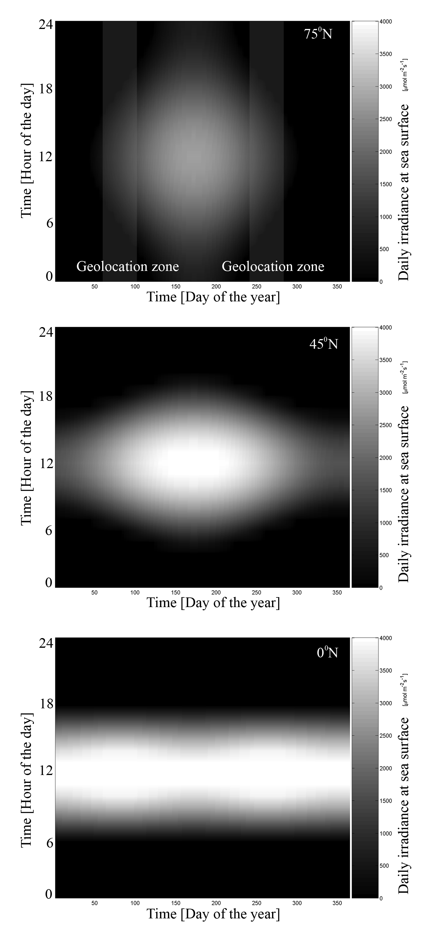
Figure 2.
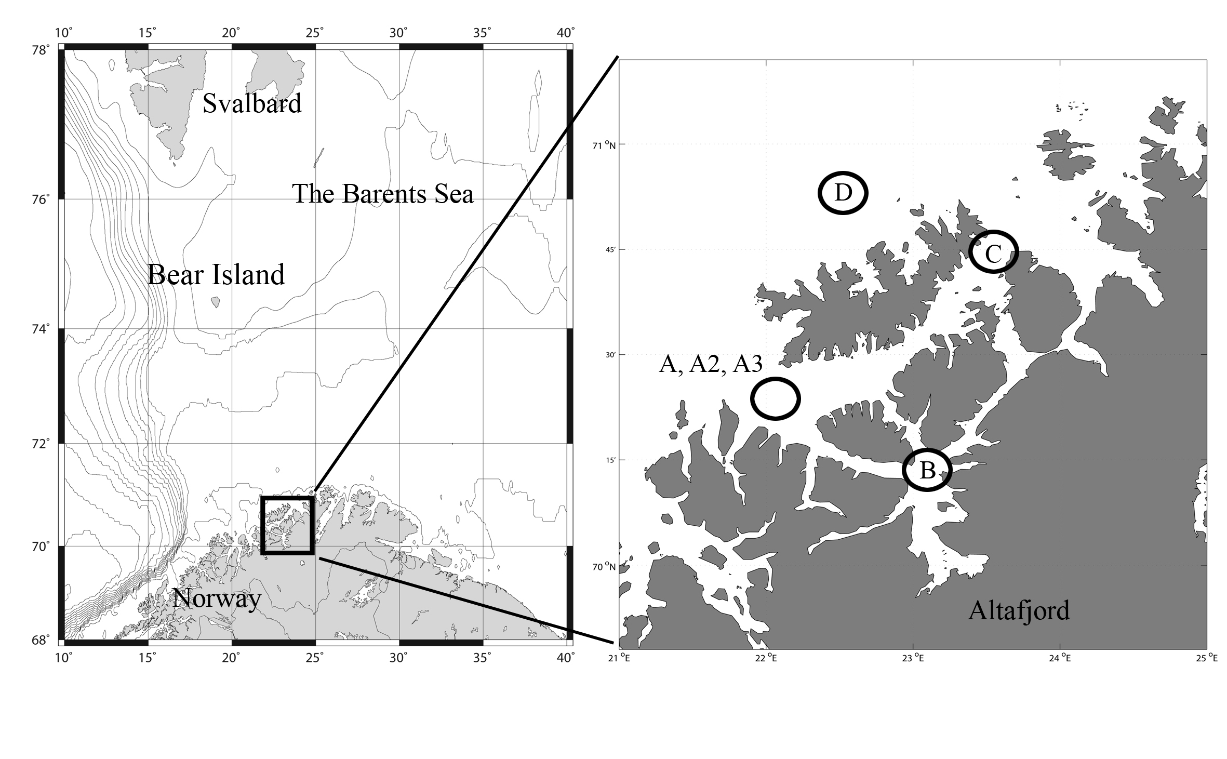
Figure 3
(see attached)

Figure 4
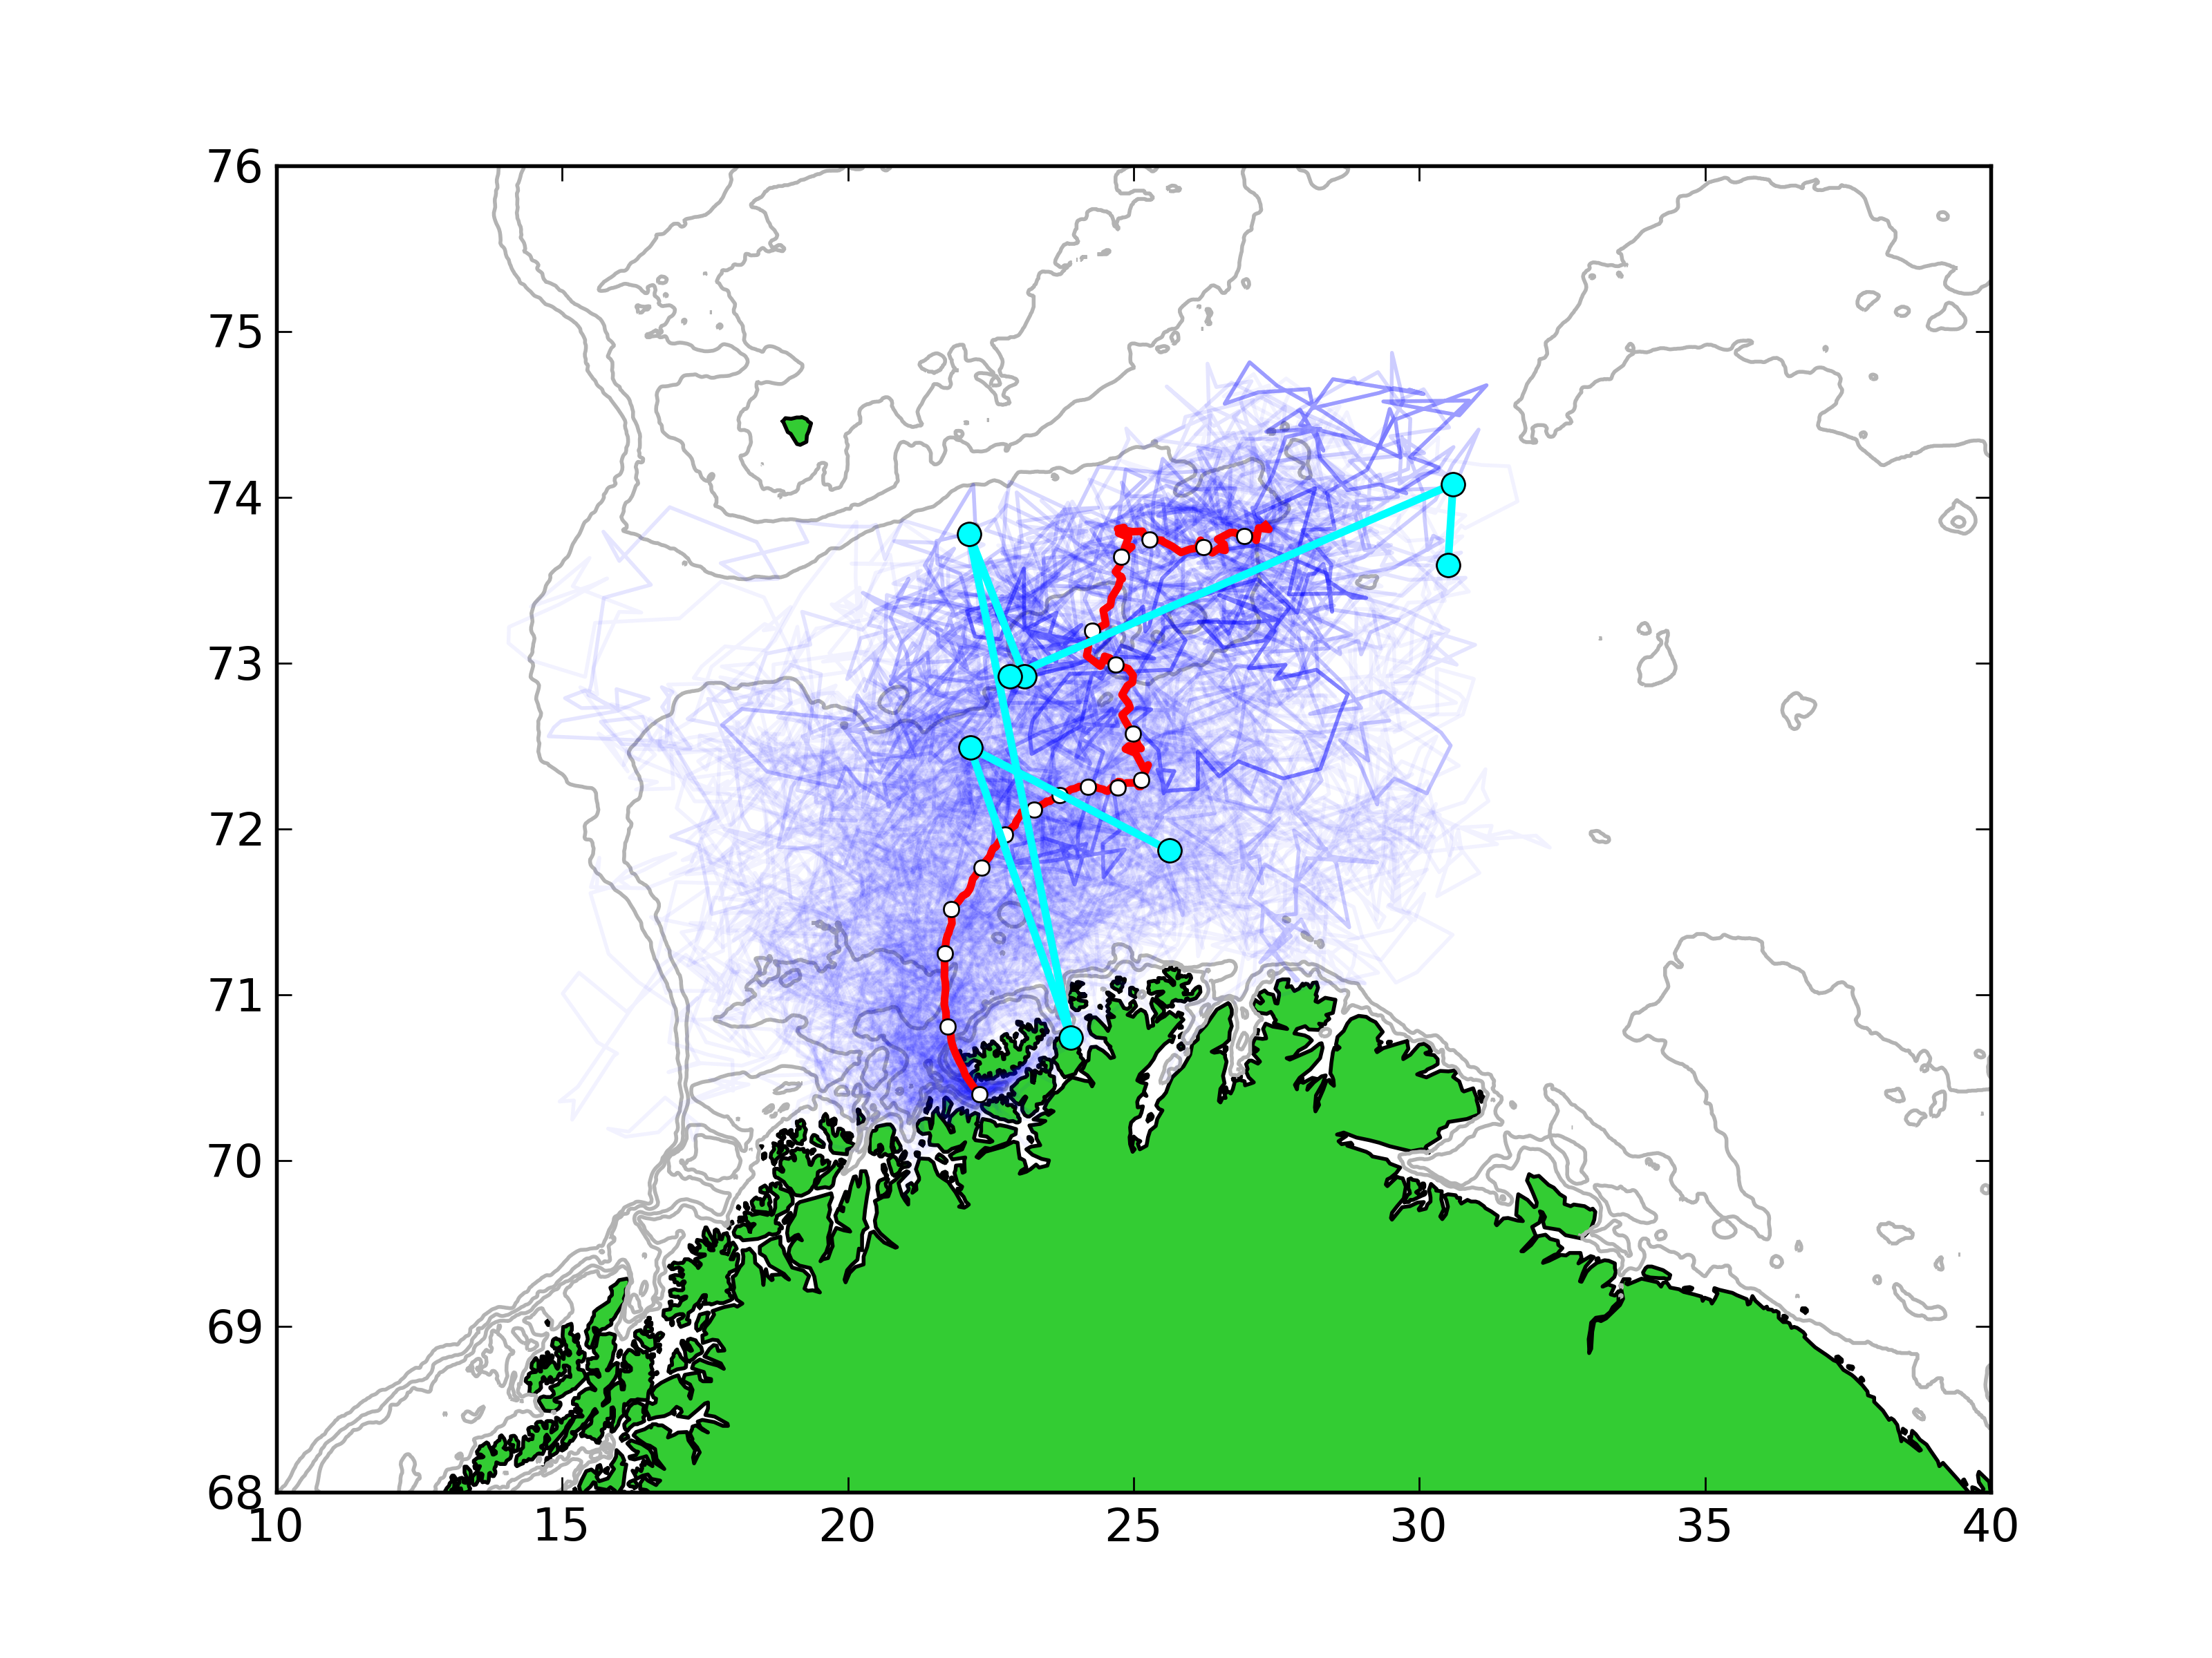
Figure 5
(8 panels)
Figure 6
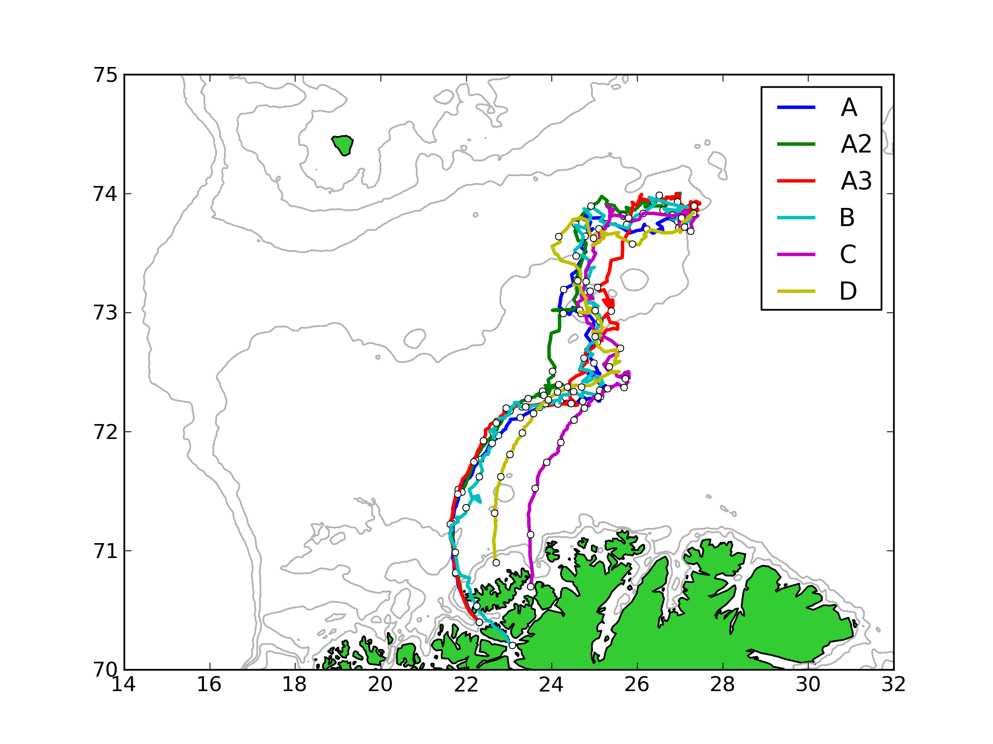
Figure 7
(sausage plot)
Figure 8
